Vietnamese National University HCMC

International University



**REPORT PROJECT**

**_ Tetris _**

**Group 31:**

Lê Quang Tuấn ITITIU19232

Phạm Lê Song Tuấn ITITIU19062

Nguyễn Đức Trí ITITIU19223

Nguyễn Gia Nam ITITIU19032

Lê Thành Chương ITITIU19086

Advisor: Dr Tran Thanh Tung.

**Course: OBJECT – ORIENTED PROGRAMMING**

**2020 – 2021**

1. **Introduction:**

* Puzzle ( Tetris game ) is the first game designed and developed by a Soviet computer scientist. He took the game’s name from the Greek prefix “ tetra ” which means four ( each set in the game) and tensis, the sport his favorite.
* Our team wants to re-enact everyone's childhood with a popular game in the early 20th century. Based on the concept of Tetris, Tetris project brings familiar images and interesting feeling when playing the game.

1. **Tutorial:**

* The objective of the game is to line up the bricks to fit 1 row on the game screen, then that row will be automatically lost and you will get points. The game will end when the bricks you stack over the allowed level.

1. **Navigation keys:**

* With simple operation we can play this game with 4 buttons on the keyboard to control the direction of the bricks.

1. **Brief:**

* Our project is coded in Java with mainly support of 2 library, “java.swing” and “java.awt”. In addition, we also use some library, “java.util”, “java.io” and “java.imageio”.
* Our project have only one package is devided into 3 main parts: Main, GUI and Figure.

1. **Important Methods:**

***Main:***

* In Program.java, main method to run the game.

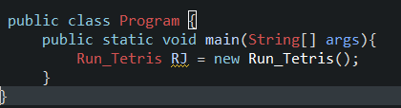

***GUI:***

* ***In the LashGame.java***

1. Create image for created text:

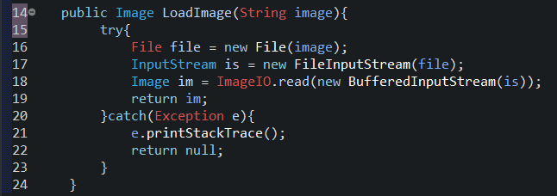

* ***In the Tetris.java:***

1. *Tetris():* Display the image interface of game with the method.

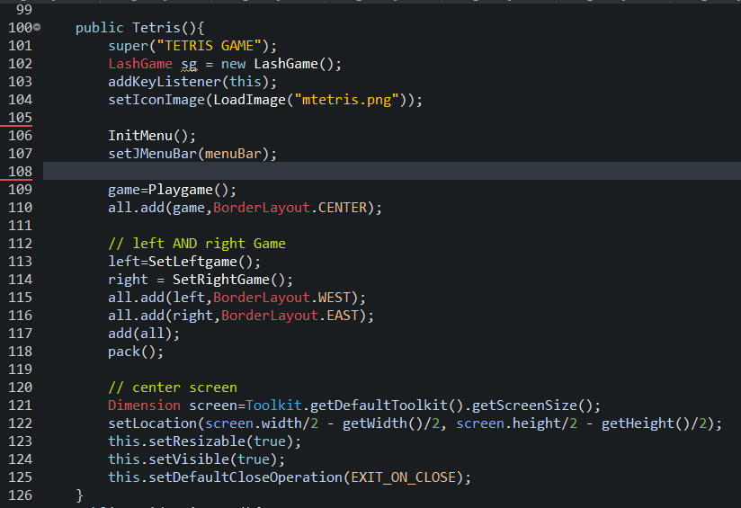

1. *InitMenu():* Display menu ( Struction board).

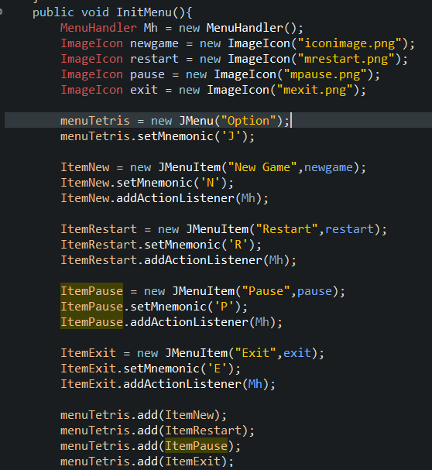

1. *Playgame():* Display the frame in the middle of the game.

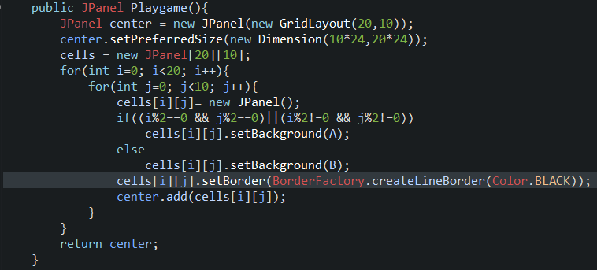

1. *SetLeftgame():* Displays details on the left part of the screen contaning pictures with brick blocks and sets the color for those text blocks.
2. *SetRightgame():*

+ Display details on the right part of the screen with JButton method pressing the keyboard to help faster operation.

+ Display the score on the frame and the level that be increased when the score added.

+ Display the next brick block while playing the game after completement one block.

1. MoveLeft(), MoveRight(), MoveNext(), MoveRotation(): Moving blocks.
2. nextNow(): When the brick blocks lands, another brick blocks will appear.

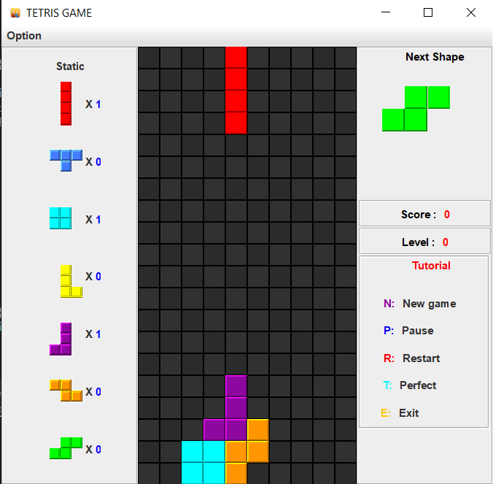

Playgame()

nextNow()

InitMenu()

SetRightgame()

SetLeftgame()

* ***In the Run_Tetris.java:***

1. *Xoa1(int i):* Display the color when remove the row that you stack the bricks fully. It make the player feeling eye – catching.

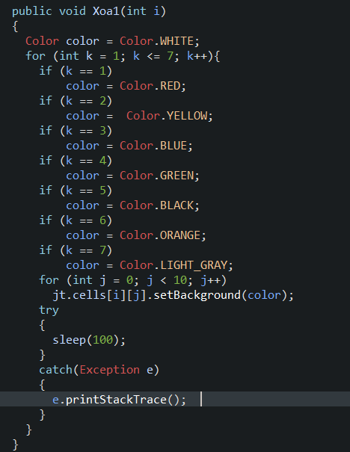

1. *Xoa2():* Set alternating colors for the cells on the game screen.

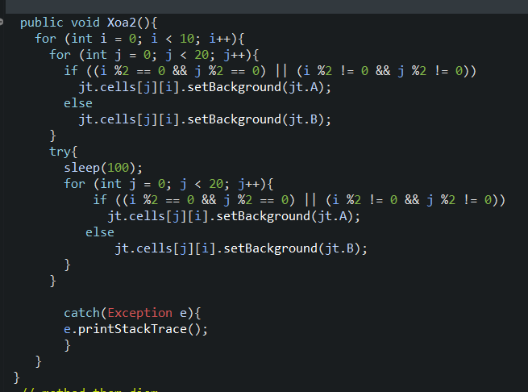

1. *AddScore():* After remove a row, the score will be added 100 points.

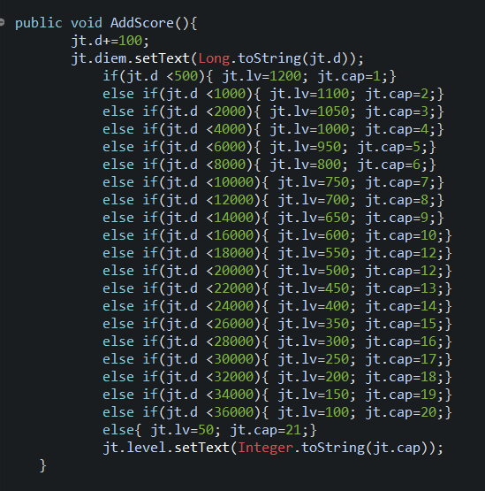

1. *Xoa(int a[]):*Deleting the row that have full bricks.

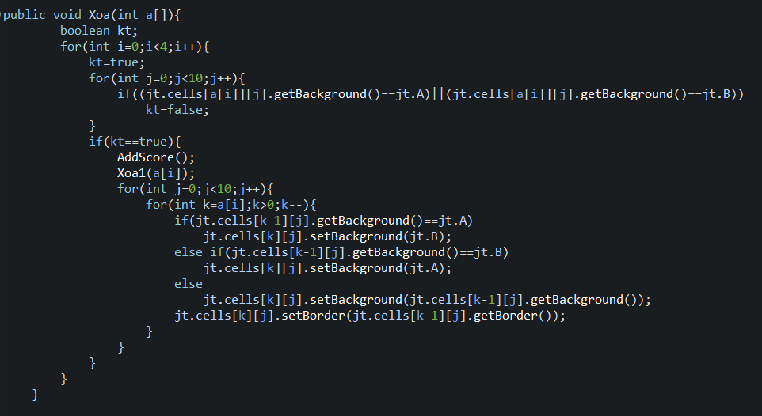

1. *nextShape():* Show the next brick after landing previous brick.

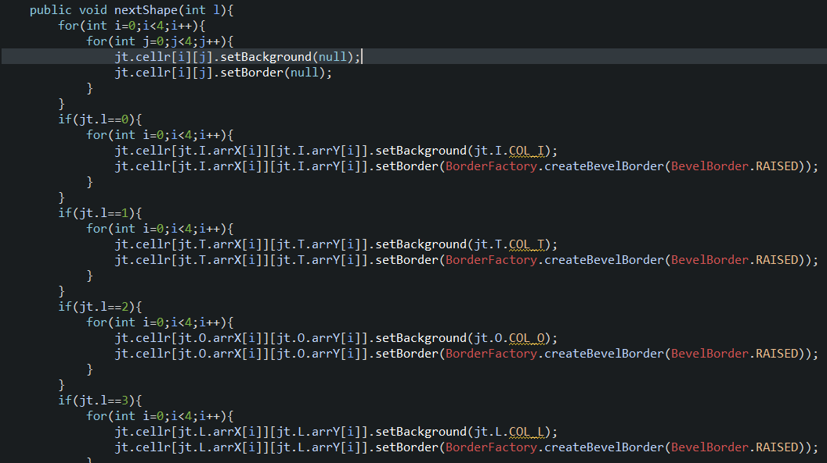

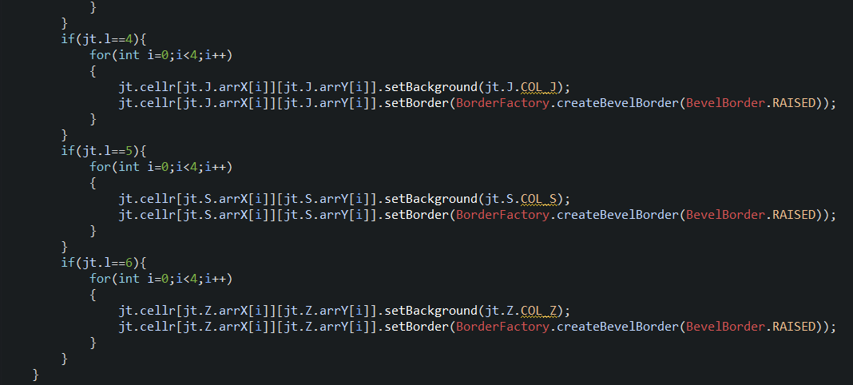

1. *overGame():* When the bricks stackover be crossed above the allowed height, the game is over and the bricks are deleted on game screen.

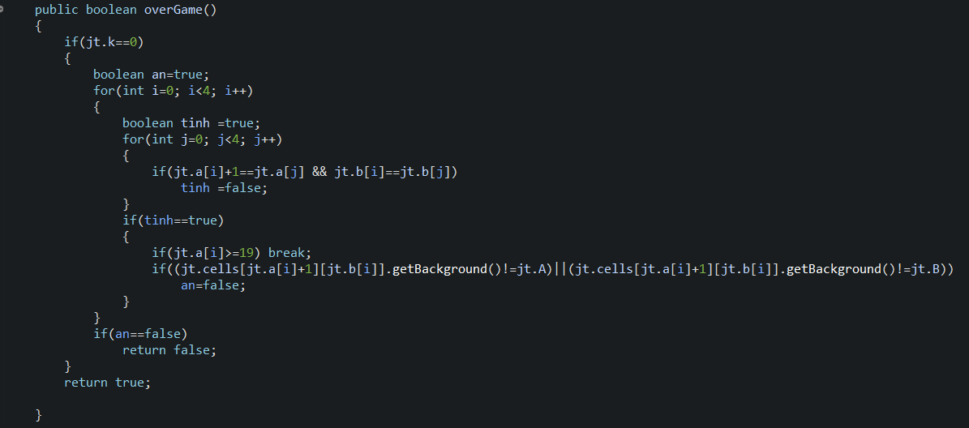

1. *Run_Tetris():* Locate and move virtual images.

***Figure***

+ In the class Figure, we set this class is abstract and set color, coordinates and rotation. Then the subclasses Figure will inherit that characteristics and create the bricks.

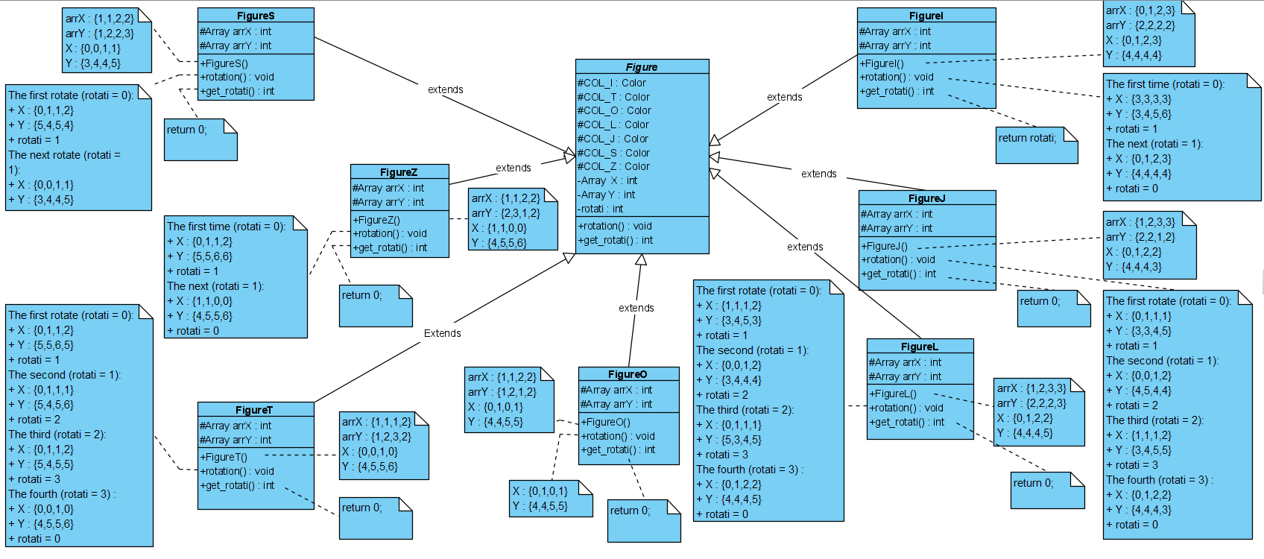

1. **Active map of Tetris game.**

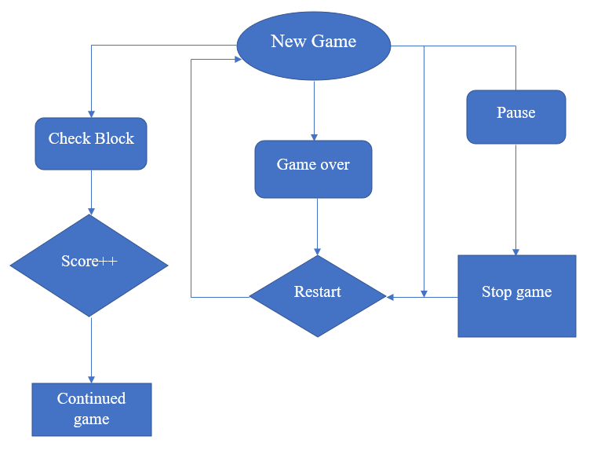

1. **Conclusion.**

* Tetris Game that was build by object – oriented method is more easier and locially than traditional – method. This shows cleary polymorphism, inheritance, encapsulation, data abstraction of OOP and the realationship between Shape, Board or other shapes together is linked tightly and systematically. Besides that, learning more knownledge out of the limited of this course is one of the important things to do while performing this project.

__________THE END__________